Bytewise Fellowship

Data Science

Task 1

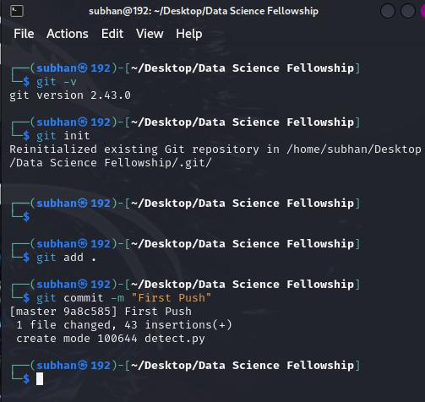Syed Subhan Shah Bokhari

* Installed version of Git, which is 2.43.0.
* Initialized a Git Repository (git init)
* Initialized a new Git repository in the directory /home/subhan/Desktop/Data Science Fellowship.
* Adding Files to Staging (git add.) (. Means all new files)
* Staging all files in the current directory for the next commit.
* Committing Changes (git commit -m "First Push"):
* Committed the staged files to the repository with the message "First Push". The commit ID is 9a8c5851, indicating 1 file changed with 43 insertions.